Identify the EPIC, User-stories and acceptance criteria

EPIC:

| **Epic: user Properties** | | |
| --- | --- | --- |
| Story: Successful User Registration | Story: Successful User login |  |
|  |  |  |

Story: Successful User Registration

As a user with valid phone number I should be able to sign up the page .

After entering the phone number, user should enter the Name and Email address.

After clicking on continue OTP should be generated & Use that OTP to verify.

User should be able to add his/her basic details in “basic profile” section.

Story: Successful User login

As a user with valid phone number and OTP I should be able to login into the website.

As a user with valid phone number and Paasword I should be able to login into the website.

| **Epic: Property activities** | | |
| --- | --- | --- |
| Story: Buying the Propety In the required location | Story: Renting the Propety In the required location | Story: Commercial Buy/ Rent a property for commercial purpose |

Story: Renting the Propety In the required location

As a user after successfully logging into the page , user should be able to click on RENT option.

Then I should select the major City and search upto three localities or landmarks in major city to get accurate required places.

And user should select the option of Apartment type(n BHK) from the given drop down,

select the option of availabity from the given drop down(in how many days that property will be available in number of days)

select Which type of property needed (like PG/hostel , Full house ,Flatmates)

user should be able to select any one option from the above types.

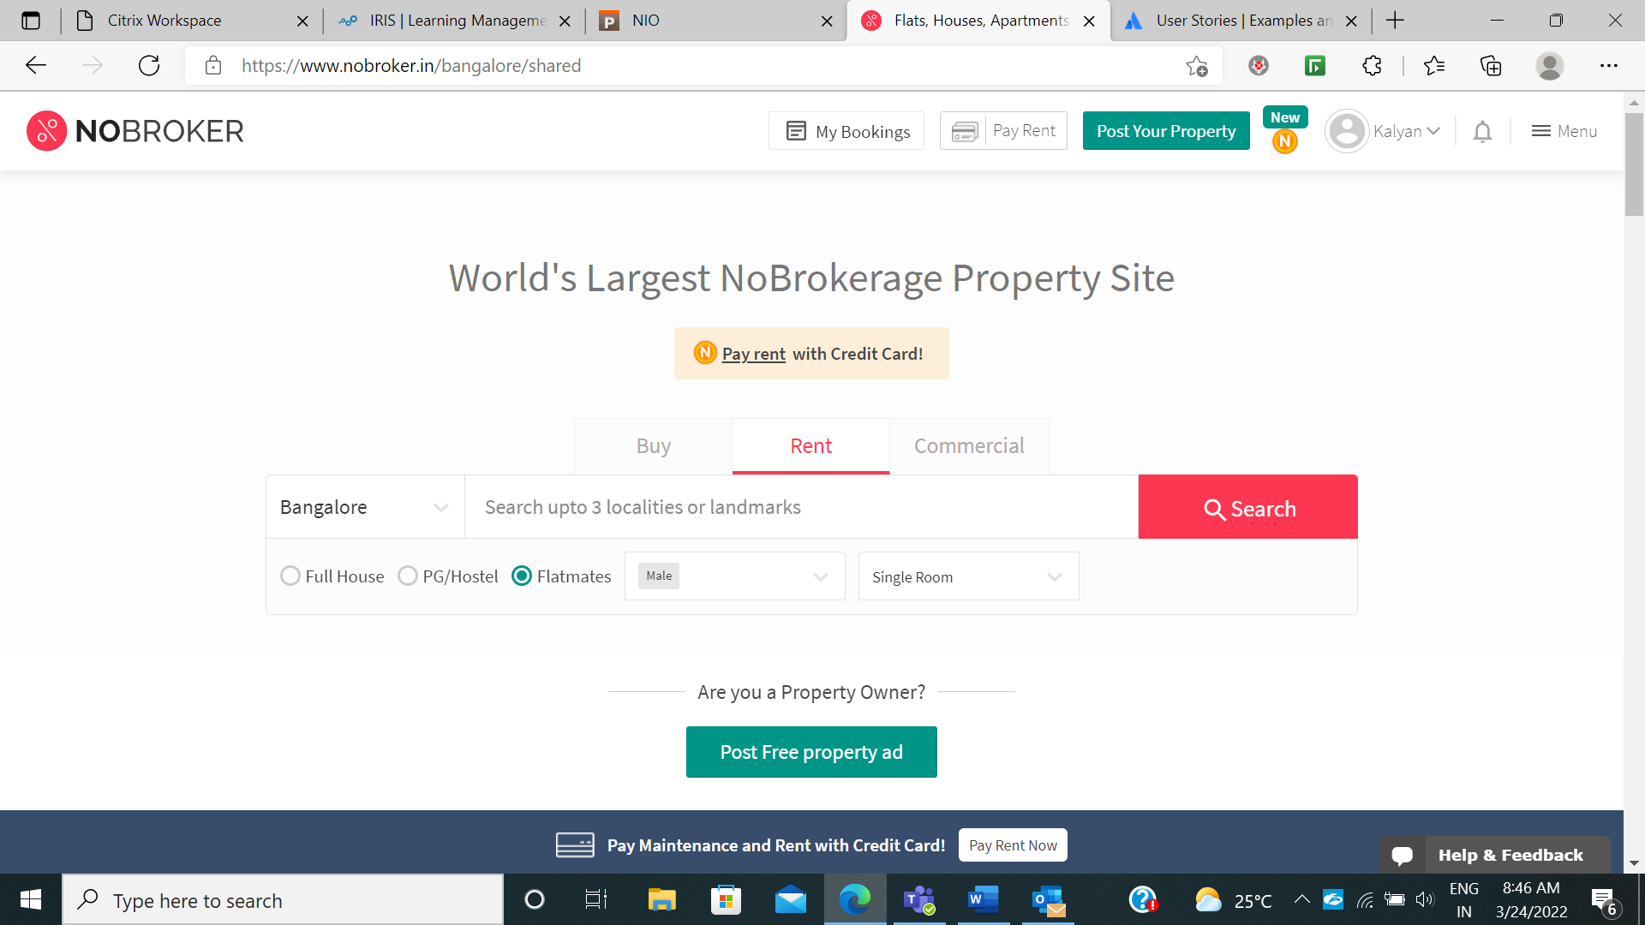

Properties of the location should be displayed then user selects the property which he/she like.

The property should display the details of it and contact details of the owner/builder.

Then user should be able to select the desired property and proceed.

Acceptance Criteria for the story

1. **User should have permission**

To enter the login credentials

To select the city.

To select the three locations/ landmarks

To select the given option related to filtering the property type

1. User should NOT have permission

To enter the login page with invalid credentilas.

To modify the property details in the webpage.

Story: Buying the Propety In the required location

As a user after successfully logging into the page , user should be able to click on BUY option.

Then I should select the major City and search upto three localities or landmarks in major city to get accurate required places.

And user should select the option of Apartment type from the given drop down,

select the option of property type from the given drop down(ready/underconstruction)

if user want a property from a new builder then the user should select the new builder option and finally click on search button.

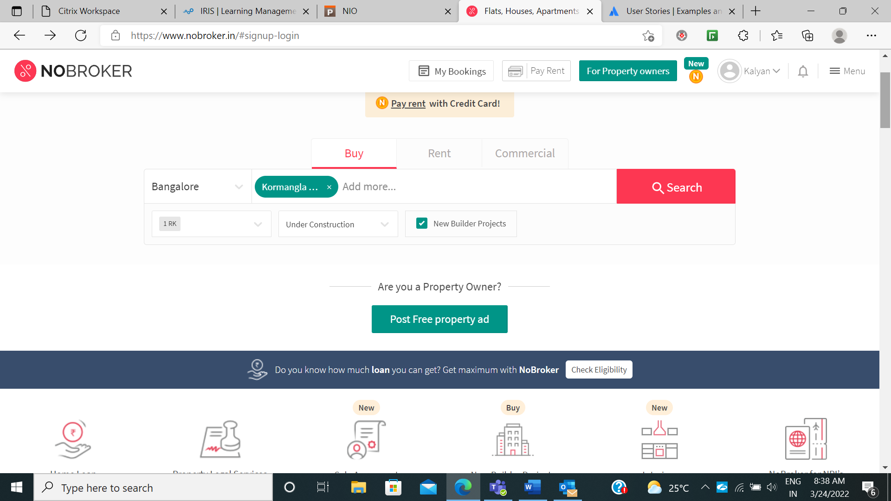

Properties of the location should be displayed then user selects the property which he/she like.

The property should display the details of it and contact details of the owner/builder.

Then user should be able to select the desired property and proceed.

Acceptance Criteria for the story

1. **User should have permission**

To enter the login credentials

To select the city.

To select the three locations/ landmarks

To select the given option related to filtering the property type

1. Author should NOT have permission

To enter the login page with invalid credentilas.

To modify the property details in the webpage.

Story: Commercial activity(Buy/ Rent)

This option is for buying/ renting a property for a commercial purpose.

As a user after successfully logging into the page , user should be able to click on Commercial option.

Then I should select the major City and search upto three localities or landmarks in major city to get accurate required places.

And user should select the option of Property typefrom the given drop down,

(should select the option for what type of commercial activity we are planning like shop, industry,showroom, resturant)

select Which type of property needed (like BUY / RENT)

user should be able to select any one option from the above types.

Properties of the location should be displayed then user selects the property which he/she like.

The property should display the details of it and contact details of the owner/builder.

Then user should be able to select the desired property and proceed.

Acceptance Criteria for the story

1. **User should have permission**

To enter the login credentials

To select the city.

To select the three locations/ landmarks

To select the given option related to filtering the property type

1. Author should NOT have permission

To enter the login page with invalid credentilas.

To modify the property details in the webpage.